**Towards humane and effective migration**

Rights areas:

* [Asylum, migration and borders](https://fra.europa.eu/en/taxonomy/term/962)
* [Borders and information systems](https://fra.europa.eu/en/taxonomy/term/1291)
* [Data protection, privacy and new technologies](https://fra.europa.eu/en/taxonomy/term/969)

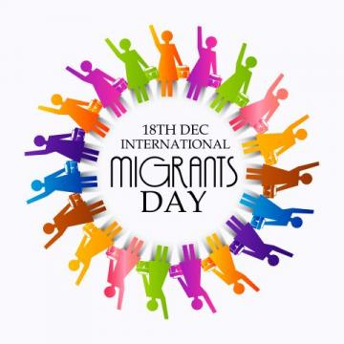sunsdesign0014 © adobestock.com, 2019

“Migration will not go away – it will stay with us,” says European Commission President Ursula von der Leyen. On International Migrants Day on 18 December, FRA joins the Commission in its call to find solutions that are humane and effective.

* + [READ MORE ABOUT COLLECTING BIOMETRIC DATA](https://fra.europa.eu/en/publication/2018/under-watchful-eyes-biometrics-eu-it-systems-and-fundamental-rights)
  + [WATCH VIDEO ON SITUATION IN GREEK HOTSPOTS](https://fra.europa.eu/en/video/2019/video-blog-michael-oflaherty-situation-greek-hotspots)

In 2019, migrants globally will top an estimated 272 million. Many move by choice.

But many others flee armed conflict, persecution, or serious human rights violations. In 2018, the number of forcibly displaced people broke 70 million for the first time ever. Many also suffer additional violence at the hands of people smugglers.

Some turn to Europe, seeking safety in the EU. However, at the EU’s external land borders, civil society and international organisations report people seeking protection being pushed back rather than channelled into asylum procedures. Migrants rescued at sea have also been caught by diplomatic wrangling over who will take them in.

And once in the EU, reception centres in some migrant hotspots face chronic overcrowding.

One area that the EU is looking at to help is smart border management using information technology. This entails large-scale databases housing personal information of people entering and leaving the EU.

Three such systems are operational: the Visa Information System, Eurodac, and the Schengen Information System. In the future, there will be six different IT systems, which will be interlinked and speak to each other.

Current systems also capture and store fingerprints. There are plans to process facial images, once the necessary legal and technical steps are completed.

However, while the collection and use of such so-called biometric data can help establish a person’s identity or track missing people, it is not without risks, as [FRA research](https://fra.europa.eu/en/publication/2018/biometrics-rights-protection) shows.

These range from not respecting human dignity when taking fingerprints to difficulties in accessing, correcting or deleting inaccurate or unlawfully stored data.

The EU strengthened safeguards in its IT systems by including fundamental rights by design and by minimising the risks of unlawful discrimination. This includes informing migrants when authorities collect their data and how they will use the data.

Safeguards also incorporate strong levels of quality assurance such as being able to ask for inaccurate data to be corrected or removed.

The EU now needs to ensure that such safeguards operate in practice as IT systems are rolled out. Only with such guarantees will these systems support migration management effectively and humanely.

In finding solutions to migration, Europe must not lose sight that migration is about people, who are often vulnerable.